***UI PATH*** ***Assignment Questions***

Primary Data types and Manipulations

1. Create a List and add 1-10 numbers in List using Loop and Print the List

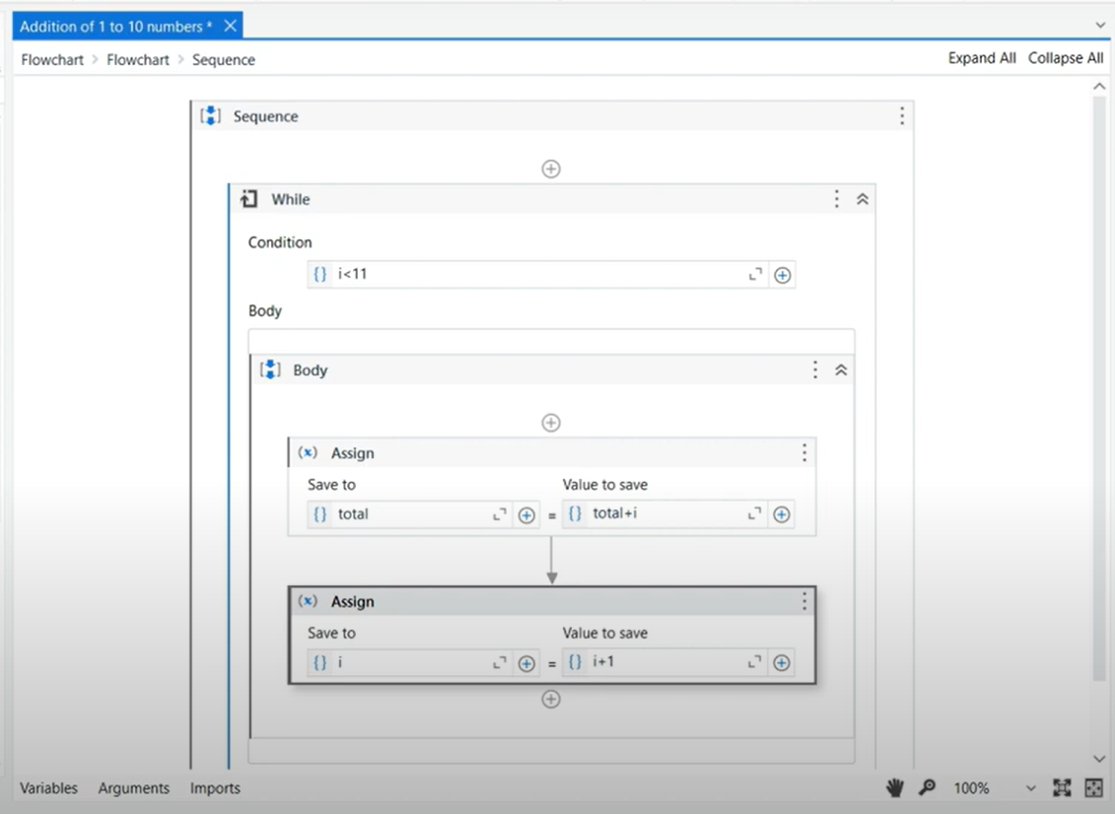

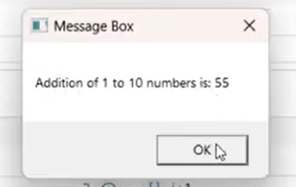

1. Create a Datatable and Print the Row Count. Increment the Value till the Value is not equal to 10 using Do while loop.

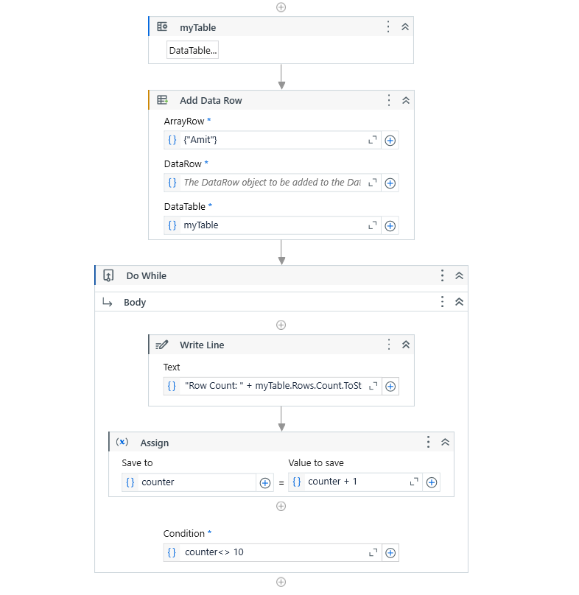

1. Create a Dictionary for a class having 5 students and print the Marks obtained. for each student

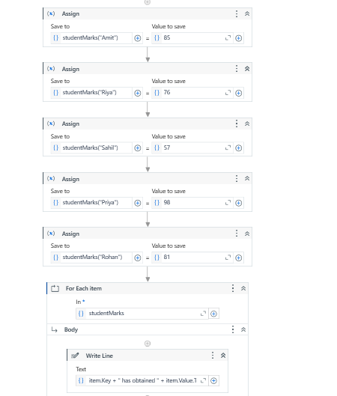

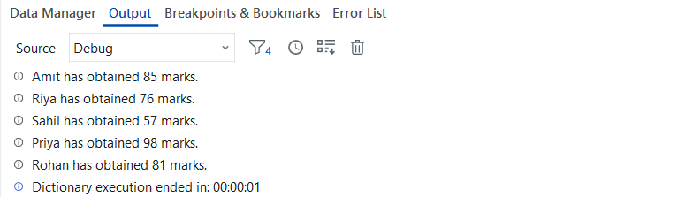



1. Consider a string H;e!llo;Eve;ry;one! and Print the output as - Hello Everyone.

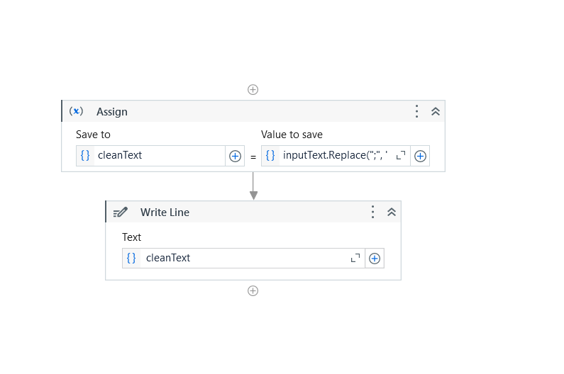

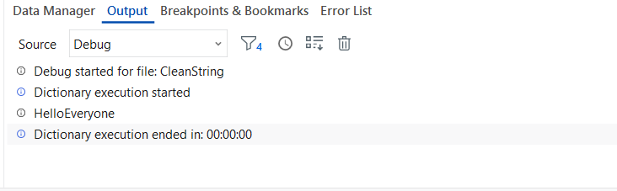



Automation Activities

Activity 1

1. Open browser, search "Java" and print the text of the first URL. Return to Home page and now search "Selenium", click on the first URL.
2. Create three different sequences files:

* seq file 1 - Ask the user to input Full Name
* seq file 2 - Ask the user to input Age
* seq file 3 - Reuse the first two sequence files and print the first name of the user, also check if the user is an eligible voter or not.

Activity 2

1. Download and save the attached excel at some location.

[Financial Sample](https://geminisolutionsindpvtltd-my.sharepoint.com/:x:/g/personal/raja_arora_geminisolutions_com/ETg-NFj_gatKtWmwByyitOMB1qM_P7c--W6FPpDI8QIuqQ?e=dAIdPi)

1. Open the excel and read the content.
2. Find the highest sale made by the country each year.

Example - In year 'YYYY' company 'xyz' made highest sale of $ 202.

1. Once you have identified the highest sale. Highlight the complete row in red color.
2. Find all the unique country name and Segment and store it in a separate excel Sheet.

**Expectation -**

1. Workflow should be reusable.

2. Variable name should be in lower camelCase.